Financial Valuation, HW 4
Dr. Feng
Please use the include Excel template to finish the work.
Question 4-1
Valuing Commercial Real Estate
Glades Properties is a limited partnership formed with the express purpose of investing in commercial real estate. The firm is currently considering the acquisition of an office building that we refer to simply as building B. Building B is very similar to building A, which recently sold for $36,960,000. Glades has gathered general information about the two buildings, including valuation information for building A:

Buildings A and B are similar in size (80,000 and 90,000 square feet, respectively). However, the two buildings differ both in maintenance costs ($23 and $30 per square foot) and rental rates ($100 versus $120 per square foot). At this point, we do not know why these differences exist. Nonetheless, the differences are real and should somehow be accounted for in the analysis of the value of building B using data based on the sale of building A. Building A sold for $462 per square foot, or $36,960,000. This reflects a sales multiple of six times the building’s net operating income (NOI) of $6,160,000 per year and a capitalization rate of 16.67%.
- Using multiple of value / size to determine the value of building B. Please replicate the answer with excel formula.
- Using multiple of NOI to determine the value of building B.
- If the risk-free rate of interest is 5.5% and the building maintenance costs are known with a high degree of certainty, what value should Glades Properties place on building B’s maintenance costs? How much value should Glades Properties place on building B’s revenues and, consequently, on the firm?
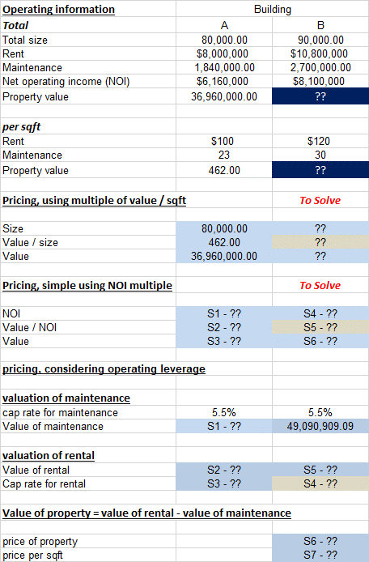

Question 4-2
Mini-Case Valuing Conoco Phillips’ Acquisition of Burlington Resources
Suppose that you were working as an equity analyst in 2005 and were assigned the task of valuing the proposed acquisition, which is described in the following press release:
Houston, Texas (December 12, 2005)—ConocoPhillips (NYSE: COP) and Burlington Resources Inc. (NYSE: BR) announced today they have signed a definitive agreement under which ConocoPhillips will acquire Burlington Resources in a transaction valued at $33.9 billion. The transaction, upon approval by Burlington Resources shareholders, will provide ConocoPhillips with extensive, high-quality natural gas exploration and production assets, primarily located in North America. The Burlington Resources portfolio provides a strong complement to ConocoPhillips’ global portfolio of integrated exploration, production, refining, and energy transportation operations, thereby positioning the combined company for future growth.
In his letter to ConocoPhillips shareholders contained in the company’s 2005 annual report, CEO Jim Mulva described the rationale for the proposed Burlington acquisition as follows:
Burlington’s near-term production profile is robust and growing, plus Burlington possesses an extensive inventory of prospects and significant land positions in the most promising basins in North America, primarily onshore. With this access to high-quality, long-life reserves, the acquisition enhances our production growth from both conventional and unconventional gas resources.
Specifically, our portfolio will be bolstered by opportunities to enhance production and gain operating synergies in the San Juan Basin of the United States and by an expanded presence and better utilization of our assets in Western Canada. In addition to growth possibilities, these assets also provide significant cash generation potential well into the future.
Beyond adding to production and reserves, Burlington also brings well-recognized technical expertise that, together with ConocoPhillips’ existing upstream capabilities, will create a superior organization to capitalize on the expanded asset base. We do not anticipate that the $33.9 billion acquisition will require asset sales within either ConocoPhillips or Burlington, nor should it change our organic growth plans for the company. We expect to achieve synergies and pretax cost savings of approximately $375 million annually, after the operations of the two companies are fully integrated.
We anticipate immediate and future cash generation from this transaction that will aid in the rapid reduction of debt incurred for the acquisition and go toward the redeployment of cash into strategic areas of growth. Burlington shareholders will vote on the proposed transaction at a meeting on March 30, 2006.
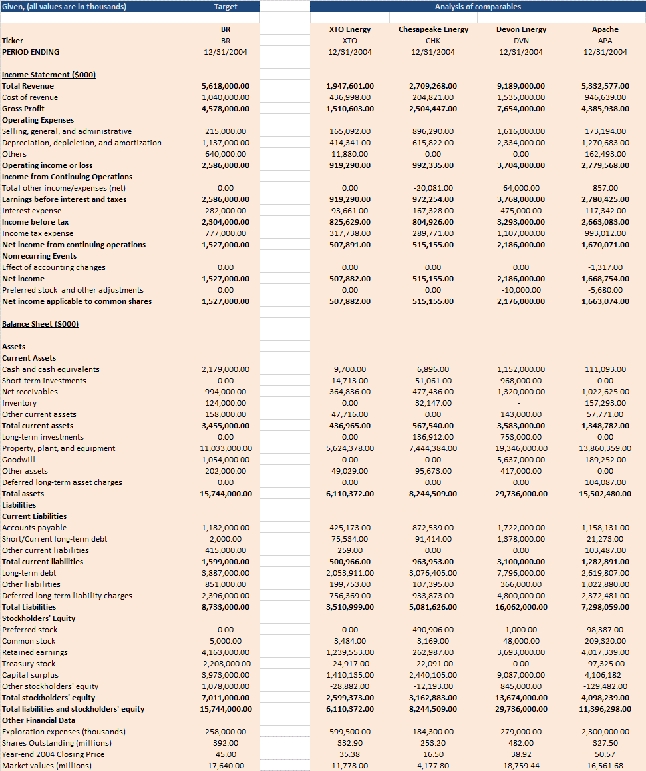
- Estimate EBITDA, P/E ratio, EV / EBITDA ratios.
- Estimate the Enterprise value and equity value using the comparable EV/EBITDA ratios.
- Estimate the equity value using the comparable P/E ratios
- Compare the market price of the target company with the value estimates using EV/EBDITA ratio and P/E ratios.
Please use the attached excel template for your solution.
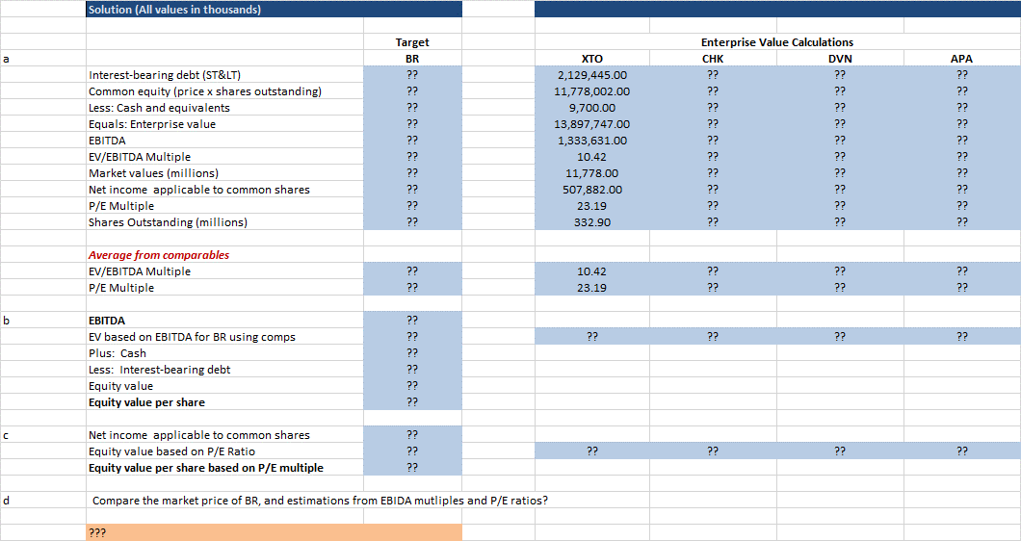
Question 4-3
Follow the example in Q4-2, work out the relative valuation for your target company in the project.
- For your target company, also pick three to four companies in the same industry for comparison.
- Collect financial statement for both the target company and its comparables.
- Estimate EBITDA, P/E ratio, EV / EBITDA ratios for both the target company and its comparables.
- Estimate the Enterprise value and equity value using the comparable EV/EBITDA ratios.
- Estimate the equity value using the comparable P/E ratios
- Compare the market price of the target company with the value estimates using EV/EBDITA ratio and P/E ratios.

